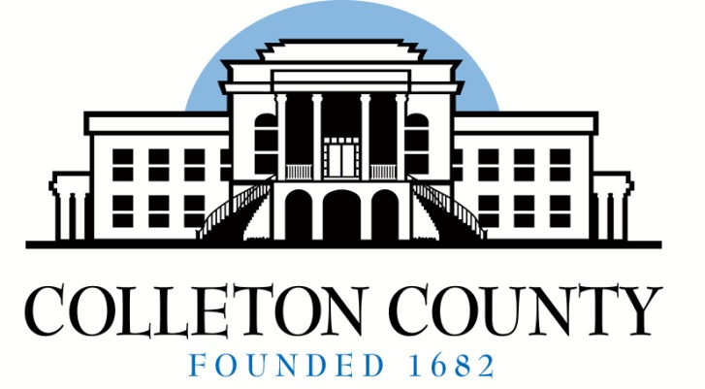

BOARD MEMBERS

Queenie L. Crawford
Chairperson
Celia S. Price
Kimber L. Santorella
Patricia A. Grant
Charles B. Davis
Janis K. Blocker
Timothy D. Hamilton

Angela G. Upchurch
Director
aupchurch@colletoncounty.org

2471 Jefferies Hwy
Post Office Box 97
Walterboro, SC 29488

Telephone: (843) 549-2842
Facsimile: (843) 549-2812

Board of Voter Registration and Elections

2024 Quarterly Board Meeting Schedule

The Colleton County Board of Voter Registration and Elections holds regular meetings on the second Tuesday in the months of March, June, September and December at 5:30 p.m. Quarterly board meetings are held at this office located at 2471 Jefferies Hwy., Walterboro, S.C.
** The time, dates and location are subject to change. Special meetings are held as needed. **

March 12, 2024

**June 13, 2024
Meeting starts immediately following Canvass & Certification of June 11, 2024 Primary.

September 10, 2024

December 10, 2024

