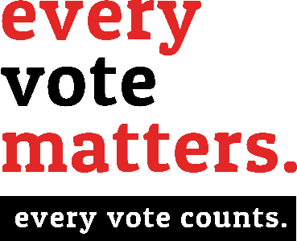 Be A Poll

W O R K E R
Call 843-549-2842 TODAY

Want to get paid to do a good thing? You can earn money as a poll worker — and the experience be rewarding!
If you qualify and are chosen to serve as an election worker, you could earn $135 just for helping out.
And you’d be serving your community —
Being a poll worker is a fun opportunity to meet new people and to participate in the election procedures. Besides, your neighborhood needs more people like you to work at the polls. Colleton County Registration & Elections must recruit and train hundreds of poll workers in communities across the county every election year.
Your county election officials can teach you everything you need to know to do the job. You just need to meet (but not limited to) a few requirements to be selected:
- You must be a U.S. citizen;
- You should be at least 16 years old
- If you are 18 or over, you must also be registered to vote in South Carolina

- I can report to the polling location by 6am on Election Day.
- I can attend a 3-hour training session
- I can work until the polls close after 7pm on Election Day.
- I can work at any polling location in Colleton County.
- I am at least 16 years old. (If 18, must be registered to vote in SC).

Name:

Mailing Address:

City: State: Zip:

Email:

Daytime Phone: Date of Birth:

Colleton County Board of Voter Registration & Elections Board Use Only
843-549-2842 cwilliams@colletoncounty.org

Angela Upchurch, Director
Cynthia P. Williams, Deputy Director

